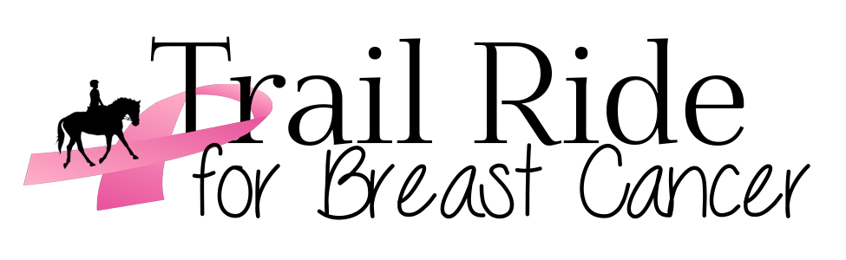

DATE: SATURDAY AUGUST 11, 2018

Cost: $55.00/rider (Includes lunch)

RIDER NAME: ________________________ HORSE’S NAME: ________________
MARE/GELDING (No Stallions please)

Thoroughbred________________________________ Racing Name

Standardbred ________________________________ Racing Name

ADDRESS: ____________________________________________________________

_______________________________________ P.C. __________________

EMAIL: ______________________________________________________

PHONE #: ____________________ HEALTH CARD #: ______________________

OEF #: __________________________________ (make sure to sign page 2 waiver)

OTHER INSURANCE____________________________________________________

NUMBER OF RIDERS IN YOUR GROUP: __________

Please indicate lunch preference: choose (1) only (+ drink + chips)

___ Hamburger ___ Hotdog ___ Peameal ___ Veggie
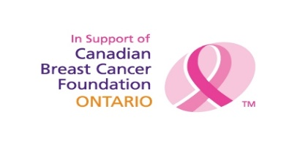
Payment to be cash or cheques (payable to Debra Moore) and can be mailed to:
Debra Moore, 19782 Airport Rd, Caledon, Ont L7K 0A3
Email: rebel1312@bell.net or call 416 407-6695
www.trailrideforbreastcancer.weebly.co
TRAIL RIDE FOR BREAST CANCER
ACKNOWLEDGEMENT OF RISK AND RELEASE OF LIABILITY

Every person must read and understand this form before participating in this trail ride.

Initial each item below after reading and understanding the item:

- I understand there are inherent DANGERS, HAZARDS and RISKS (collectively called RISKS) associated with equine activities and injuries resulting from these “RISKS” are a common occurrence.
- I acknowledge that the inherent “RISKS” of equine activities mean those DANGEROUS conditions which are an integral part of equine activities, including but not limited to:
- The propensity of any equine to behave in ways that might result in injury, harm or death to persons on or around them and to potentially collide with, bite or kick other animals, people or objects.
- The unpredictability of an equine’s reaction to such things as sounds, sudden movement, tremors, vibrations, unfamiliar objects, persons or other animals and hazards such as subsurface objects.
- The potential for other participant(s) to act within their ability or to maintain control over an equine.
- I freely accept and fully assume all responsibility for the inherent “RISKS” and the possibility of personal injury, death, property damage or loss resulting from my participation in equine activities.
- I acknowledge that it remains my sole responsibility to act in such a manner as to be responsible for my own safety and to participate within my own limits.
- I acknowledge the “HOSTS” and “Organizers” of this trail ride have the right to refuse to allow my participation in the equine activity if they deem that my actions may be a cause for safety concerns to myself or others involved in the activity.
- In addition to consideration given for my participation in an equine activity, I and my heirs, executors, administrators and assigns (collectively called my “Legal Representatives”) agree:
- To waive all claims that I might have against the “HOSTS” and “Organizers” of this trail ride; and
- To release the “HOSTS” and “Organizers” from any and all liability for any loss, damages, injury, or expense that I or my “Legal Representatives” might suffer as a result of my participation due to any cause whatsoever including any negligence on the part of the “HOSTS” or “Organizers” of this trail ride; and
- TO HOLD HARMLESS AND INDEMNIFY THE “HOSTS” OR “ORGANIZERS” of this trail ride from any and all liability for property damage or personal injury to any third party which might result from my participation in this trail ride.

Before signing this form, I have read it (as indicated by my initials above) and I stated that I understand it, I know that signing this form waives certain legal rights I or my “Legal Representatives” might have against the “HOSTS” or “Organizers” of this Trail Ride.

_________________________________ _____________________ _____________________
Signature of Participant Date Witness
Parent if under 18 years old

** HELMETS MANDATORY FOR ANYONE UNDER THE AGE OF 18 YEARS OLD **

