9th Annual Trail Ride for Breast Cancer
Sponsor Request

Sponsor Name _____________________________Contact Name: _________________

Street Address ___________________________________________________________

Town _____________________________ Province/State: _______________

Postal Code/Zip Code: _________________________

Telephone ( _______ ) _________________________________________________

Email ____________________________________________________________

Donation Amount/Product: ____________________________________________________

Ride to be held Saturday, August 11, 2018 in the Dufferin Forest, located just north of Mansfield. There will be approx 150 riders/horses and volunteers attending from all over southern Ontario. Last years’ ride raised $ 15,000.00 with 90 riders/horses. With your support we have now raised $118,000.00.

We are looking for any type of donation: cash, gift certs, product, your time, advertising etc.

Please check out our website: www.trailrideforbreastcancer.weebly.com

Your donation will be used as prizes for various contests, on-line auction, raffles & door prizes, or to help cover the cost of running this event. (use of forest, liability insurance, portable toilets) Please help make this ride a great success. Our goal is now to raise $150,000.00 by our 10th Anniversay.
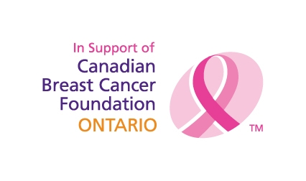
Please forward to: Debra Moore, 19782 Airport Rd, Caledon, Ontario L7K 0A3
Cell: 416 407-6695, Fax 519 942-3494, email: rebel1312@bell.net

